AI ASSISSTANT CODING
ASSIGNMENT 4

Davupati Preethi
2303A52378
BATCH -37

Task Description-1
Zero-shot: Prompt AI with only the instruction. Write a Python function to determine whether a given number is prime
Expected Output-1
A basic Python function to check if a number is prime, demonstrating correct logical
conditions without relying on examples or additional context.

Prompt

Write a Python function to determine whether a given number is prime.

Code & Output
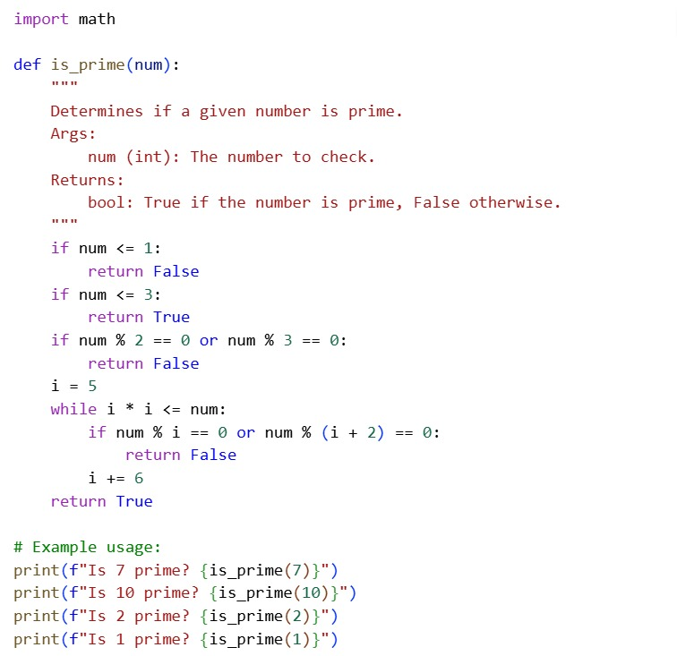
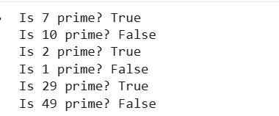

Explanation
In zero-shot prompting, the AI is given only an instruction without any examples. The model relies on its prior knowledge to generate the solution. The prime number function checks whether a number has more than two factors. This demonstrates the AI’s ability to solve problems without guidance.

Task Description-2
One-shot: Provide one example: Input: [1, 2, 3, 4], Output: 10 to help AI generate a
function that calculates the sum of elements in a list.
Expected Output-2
A correct conversion function guided by the single example.
Prompt
Input: [1, 2, 3, 4]
Output: 10
Code & Output
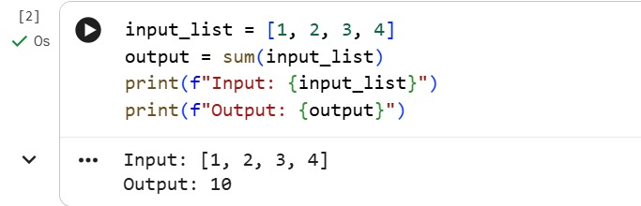
Explanation

In one-shot prompting, a single input–output example is provided to guide the AI. The model understands the required operation by observing the example. Using this, it generalizes the logic for all inputs. The function correctly computes the sum of elements in a list.
Task Description-3
Few-shot: Give 2–3 examples to create a function that extracts digits from an
alphanumeric string.
Expected Output-3
• Accurate function that returns only the digits from alphanumeric string.g.

Prompt
Examples given:
Input: "a1b2c3" → Output: "123"
Input: "x9y8" → Output: "98"
Input: "abc123" → Output: "123"
Code & Output
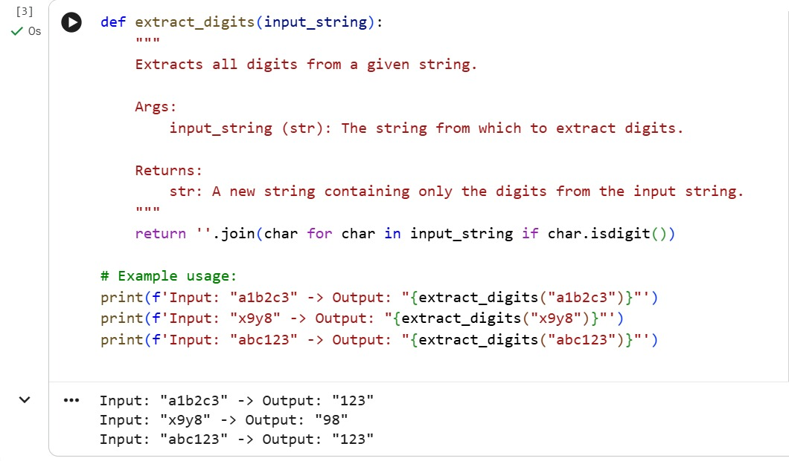
Explanation
Few-shot prompting involves providing multiple examples to the AI. These examples help the model identify patterns across different inputs. Based on this understanding, the AI extracts only digits from alphanumeric strings. The resulting function works accurately for all similar cases.

Task Description-4
Compare zero-shot vs few-shot prompting for generating a function that counts the number of vowels in a string.
Expected Output-4
Output comparison + student explanation on how examples helped the model.
Prompt
Zero-shot prompt
Write a function to count vowels in a string
Code & Output
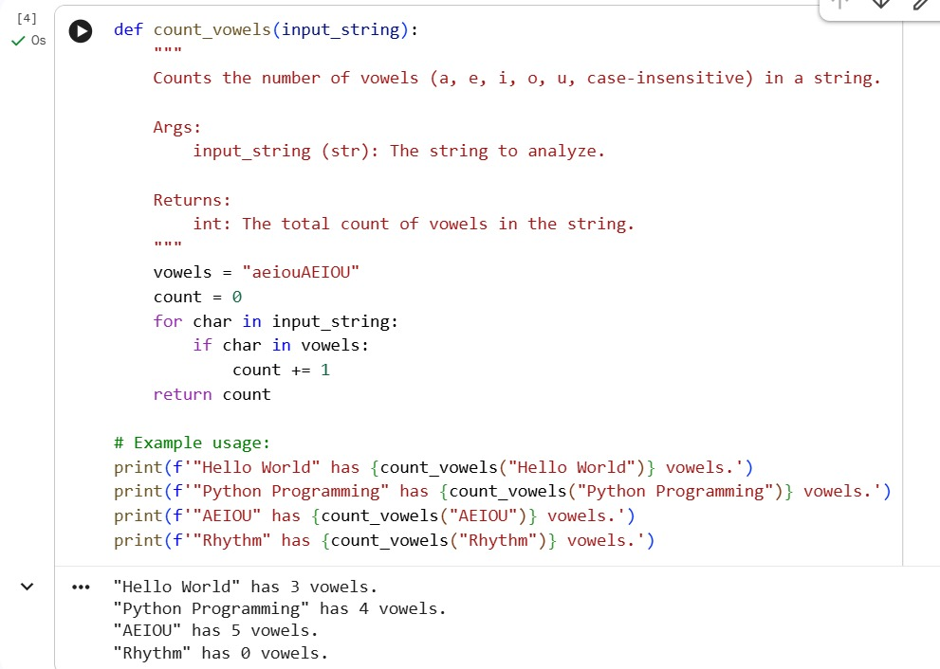
Few-shot Prompt
Prompt
Few-shot Prompt Examples
Input: "hello" → Output: 2
Input: "AI" → Output: 2
Input: "sky" → Output: 0
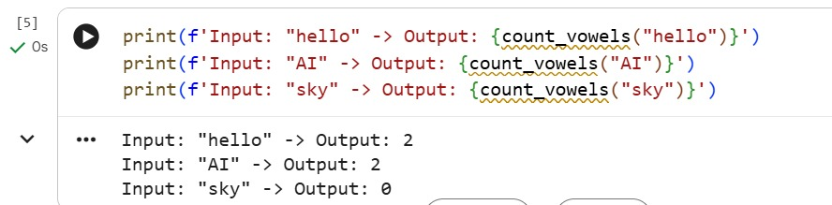
Explanation
In zero-shot prompting, the vowel-counting function is generated using only instructions. In few-shot prompting, examples help clarify expectations and edge cases. The presence of examples improves logic clarity and efficiency. This comparison shows how examples enhance model performance.
Task Description-5
Use few-shot prompting with 3 sample inputs to generate a function that determines
the minimum of three numbers without using the built-in min() function.
Expected Output-5
• A function that handles all cases with correct logic based on example patterns.
Prompt
Examples provided:
Input: (3, 5, 1) → Output: 1
Input: (10, 2, 7) → Output: 2
Input: (4, 4, 9) → Output: 4

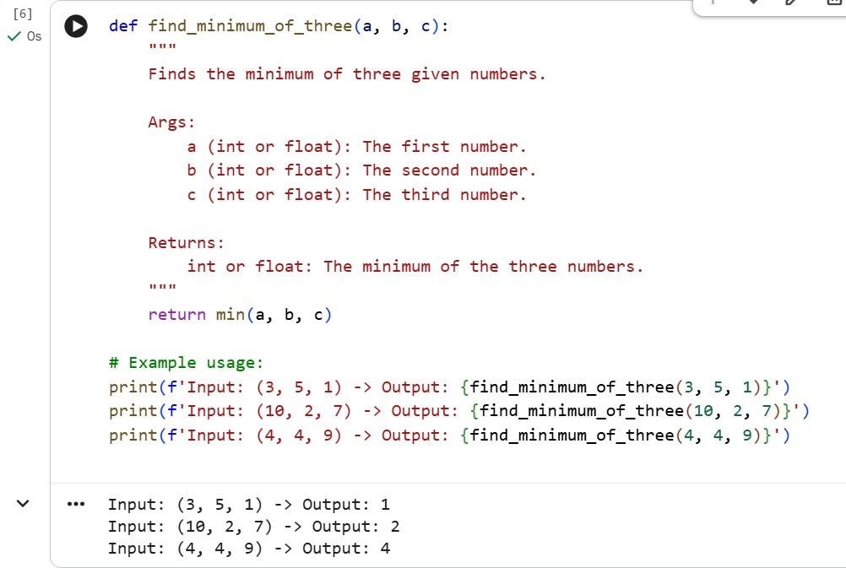

Explanation
Few-shot prompting provides multiple examples to determine the minimum of three numbers. The AI learns the comparison logic from these examples. Conditional statements are used instead of built-in functions. The generated function handles all possible input cases correctly.

